DATA ANALYST INTERNSHIP TASK 2

HERE IS LINK - https://public.tableau.com/views/internshiptask2_17543962333120/Dashboard1?:language=en-US&publish=yes&:sid=&:redirect=auth&:display_count=n&:origin=viz_share_link

SUPERSTORE SALES ANALYSIS

Overview
This report summarizes the steps taken to analyze and visualize the Sample Superstore dataset using Python and Tableau.
The focus was on creating a data storytelling dashboard supported by charts and business insights.

Tasks Completed

Key Performance Indicators (KPIs):
- Total Sales: $2.29M+
- Total Profit: $286K+
- Total Quantity Sold: 37K+

Trend Analysis:
- Created a line chart showing Sales and Profit trend by month.
- Revealed seasonal spikes in Q4 and dips during off-seasons.
Category/Sub-Category Insights:
- Created a horizontal bar chart for Sales and Profit by Sub-Category.

Tools Used
- Tableau Public (for dashboard creation and publishing)
- Google docx. For report making.

Key Outcomes
- Identified Consumer segment as the most profitable with highest orders.
- Found Phones and Chairs as top-performing Sub-Categories.
- Detected losses in certain states despite high sales (e.g., Texas).
- Revealed negative correlation between discounts and profit.
- Standard Class is the most commonly used shipping method.

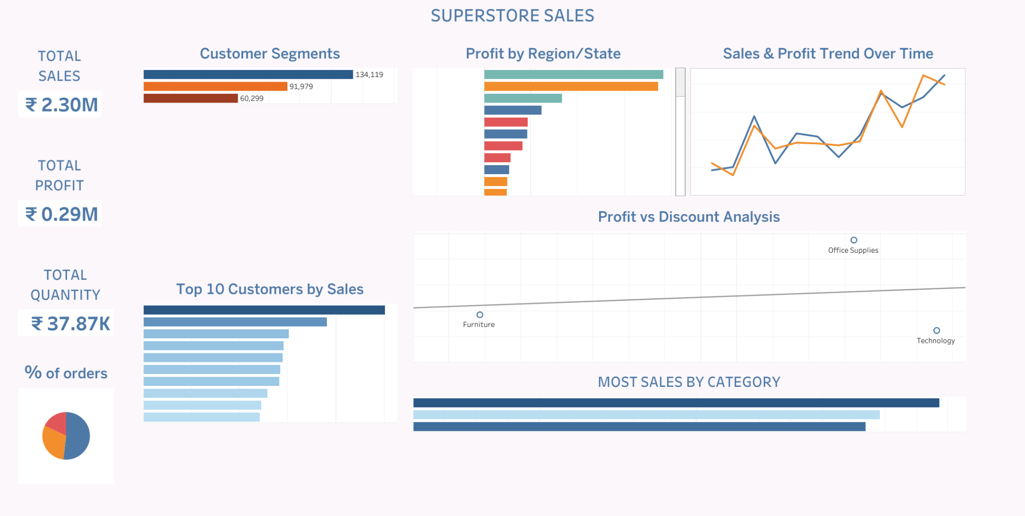

End

